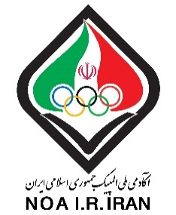
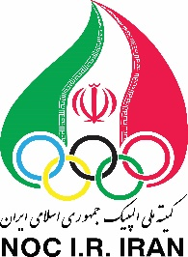

“Sports Cardiology Symposium”
Onsite & Online, 16th August 2022

Dear Colleagues,
Hereby, we would invite you to participate in “the Sorts Cardiology Symposium 2022”, onsite & online 16th August 2022.
Organized under the auspices of the sports cardiology department of the National Olympic Academy of I.R Iran along with well-known speakers from Aspetar Orthopedic and Sports Medicine Hospital and World Health Organization.
Symposium will provide an up-to-date and comprehensive approach to the cardiac screening program in athletes and an overview of cardiac exercise physiology, for physicians and allied health professionals with interest in sports cardiology.
We are looking forward to welcoming you to the above mentioned Symposium.

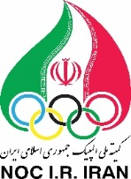
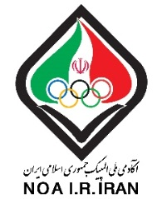
“Sports Cardiology Symposium”
Onsite & Online, 16th August 2022
Onsite& Online, 16th August 2022

Fist Name:

Last Name:

Date of birth:

Gender:

Country:

Type of registration:
Online or Onsite

Academic Degree:
Specialty: Physician or Cardiologist or Sports Medicine Specialist or Exercise Physiologist or Sports Science Specialist

Email:

Phone:

Address:

